Governance & Proposal
Overview of Governance
Organisational structure of the company
An organisational structure defines how tasks, authority and reporting lines are distributed across an organisation (The University of Sydney, 2026). Four common types exist (Mintzberg, 1979):
- Functional – staff are grouped by specialism (e.g., Engineering, Sales). Roles are clear, but silos can form.
- Hierarchical – many layers and a clear chain of command. Stable and accountable, but slow to decide.
- Flat – few or no middle managers. Fast and innovative, but roles blur as headcount grows.
- Matrix – staff report to a functional manager and a project manager. Strong collaboration, but dual authority can confuse priorities.
Lyra uses a flat, functional–matrix hybrid. With 34 staff, there are at most three management levels between any employee and the CEO (Figure 1). Every employee belongs to one of six functions – Engineering, Product & Learning Design, Finance & Operations, Security & Compliance, Sales and Customer Success – which own hiring, standards and professional development. Day-to-day work, however, happens in cross-functional product squads; for example, a retrieval-quality squad combines machine learning engineers, a learning designer and a customer success contact. This matches the culture described in About the Organisation, where engineers, learning designers and former academics sit in the same squads.
The flat layer keeps decisions fast, which a one-year-old company needs, while the matrix element prevents a silo between engineering and pedagogy that would weaken a curriculum-grounded product. The known weakness of a matrix, competing priorities, is managed by the executive team setting one ranked list of squad priorities each quarter.
Strategic decision making
Strategic decisions follow an annual planning cycle with a quarterly review. Each May the executive team turns the FY2027 objectives – eight university-wide licences, 90% renewal and gross margin above 70% – into quarterly objectives and key results (OKRs), which the Board approves. Decision rights are tiered by impact and reversibility (Weill & Ross, 2004):
- Board reserved matters – annual budget, capital raising, any single commitment over AUD 250,000, entry into new markets or segments, and accepting any risk rated Severe.
- Executive decisions (CEO with the relevant functional head) – pricing bands, model-provider contracts, hiring plans, roadmap priorities and risks rated High.
- Squad decisions – technical design inside agreed architecture principles, sprint scope and reversible experiments.
The Business Model Canvas (BMC) in AW2 shows the strategic decisions Lyra faces now (Table 1).
Table 1. Strategic decisions drawn from the Business Model Canvas
BMC block | Strategic decision | Decided by
Cost Structure | How to protect gross margin as model-inference spend grows with usage | Board sets target; Executive manages
Key Partnerships | How far to depend on a single model provider | Executive (CTO); Board if over AUD 250,000
Value Proposition | How to prove grounding and citation accuracy to institutions rather than just claim it | Executive (CPO)
Revenue Streams | Whether to keep pricing per EFTSL or move to usage-based pricing | Executive; Board approves

The proposal in the second half of this template is Lyra's answer to the first three decisions.
Organisation chart
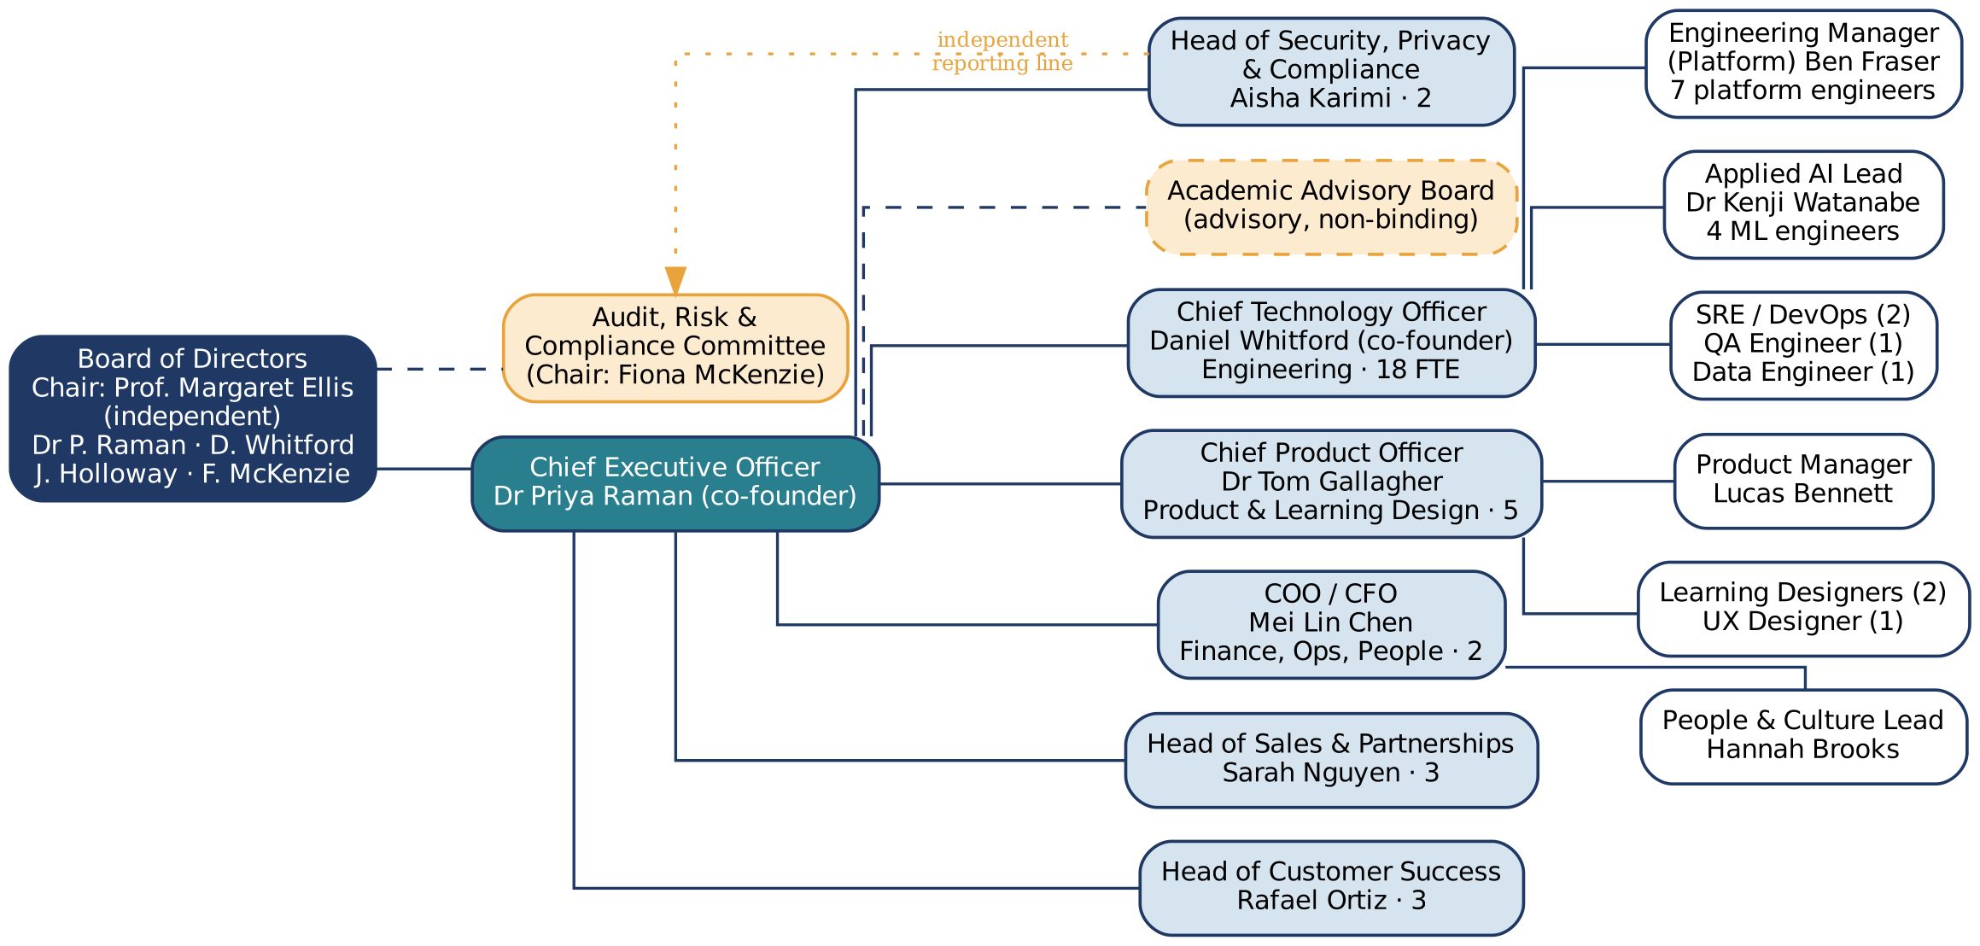
Figure 1. Organisation chart of Lyra Learning Pty Ltd (34 FTE). Dashed lines show advisory relationships; the dotted line shows the Head of Security's independent reporting line.
Lyra has a five-member Board of Directors: an independent chair who is a former Deputy Vice-Chancellor (Education), the two founders, a director nominated by the seed investor, and an independent non-executive director with cyber-security and privacy expertise who chairs the Audit, Risk & Compliance Committee (ARC). The Corporations Act 2001 (Cth) requires a proprietary company to have only one director; Lyra goes further so that independent voices and investor oversight balance the founders.
The CEO reports to the Board and leads six executives:
- Chief Technology Officer – engineering (18 staff) and the company's CIO duties.
- Chief Product Officer – product, learning design and UX (5 staff).
- COO / CFO – finance, operations and people (2 staff).
- Head of Security, Privacy & Compliance – security, privacy and compliance (2 staff).
- Head of Sales & Partnerships – enterprise sales and partnerships (3 staff).
- Head of Customer Success – onboarding, adoption and renewals (3 staff).
Three design choices stand out. First, the Head of Security, Privacy & Compliance reports to the CEO for operations but has a direct line to the ARC, so security and privacy concerns reach the Board without being filtered by executives under delivery pressure. Second, the Academic Advisory Board advises on pedagogy and the roadmap but has no decision rights. Third, engineering is the largest function, reflecting AW2's point that Lyra's intellectual property is the retrieval, evaluation and prompt layer around the model.
IT in the Governance structure
Because Lyra's product is software, IT is not a support function but a strategic enabler at the centre of the business model (The University of Sydney, 2026). Lyra has no separate CIO; instead, the CTO holds CIO accountabilities for both the product platform and internal systems.
To stop technology decisions resting with one person, Lyra runs a monthly Technology & AI Steering Committee, which acts as its IT steering committee. The CEO chairs it, and its members are the CTO, CPO, COO/CFO, Head of Security, Privacy & Compliance and Head of Customer Success. It approves technology investments and architecture principles, ranks the technology roadmap against the OKRs and tracks technology risk. AI-specific questions – which model answers a student, how answer quality is evaluated and how fairness is tested – are delegated to an AI Quality & Ethics Review Board chaired by the CPO. The Board keeps final accountability through the evaluate–direct–monitor model of ISO/IEC 38500 (International Organization for Standardization [ISO], 2024), which also matches Australia's Guidance for AI Adoption (National Artificial Intelligence Centre [NAIC], 2025). AW7 sets out the full framework.
Roles and Responsibilities
Table 2. Organisational roles and responsibilities at Lyra Learning
Role | Name (Fictional) | Responsibilities
Independent Chair of the Board | Prof. Margaret Ellis | - Leads the Board and sets its agenda  - Holds the CEO to account for strategy and performance  - Approves reserved matters (budget, capital, commitments over AUD 250,000, Severe risks)
Independent Non-Executive Director | Fiona McKenzie | - Chairs the Audit, Risk & Compliance Committee  - Brings cyber-security and privacy expertise to the Board  - Receives the Head of Security's independent reports
Investor Director | J. Holloway | - Represents the seed investor on the Board and on ARC  - Oversees runway, unit economics and fundraising
Chief Executive Officer (co-founder, director) | Dr Priya Raman | - Sets strategy, OKRs and the annual budget for Board approval  - Chairs the Technology & AI Steering Committee  - Owns relationships with investors and university executives  - Accountable for company performance and culture
Chief Technology Officer (co-founder, director) | Daniel Whitford | - Accountable IT executive for platform, infrastructure and internal systems  - Owns architecture principles, engineering standards and the technology budget  - Manages 18 engineering staff; sponsor of technology projects  - Owns model-provider relationships and technical due diligence
Chief Product Officer | Dr Tom Gallagher | - Owns the product vision, roadmap and pedagogical design  - Chairs the AI Quality & Ethics Review Board  - Manages product, learning design and UX staff; liaises with the Academic Advisory Board
Chief Operating Officer / Chief Financial Officer | Mei Lin Chen | - Financial planning, unit economics and gross-margin tracking  - Procurement, contracts, insurance and legal coordination  - Oversees People & Culture and operations; prepares Board financial packs
Head of Security, Privacy & Compliance | Aisha Karimi | - ISO/IEC 27001 information security manager and Privacy Officer under the Privacy Act 1988  - Owns the risk register, incident response and data breach assessment  - Completes university security, privacy and accessibility questionnaires  - Reports independently to the Audit, Risk & Compliance Committee
Head of Sales & Partnerships | Sarah Nguyen | - Enterprise sales to Deputy Vice-Chancellors, CIOs and faculties  - Pilot-to-licence conversion and pricing negotiations  - Partnerships with Instructure, Moodle, CAUDIT and AUPN
Head of Customer Success | Rafael Ortiz | - Onboarding, adoption and renewals; owns the 90% renewal target  - Quarterly business reviews with usage and quality evidence  - Feeds customer insight into the roadmap
Engineering Manager (Platform) | Ben Fraser | - Leads platform and integration engineers  - Owns reliability, release management and on-call rosters  - Chairs the Change Advisory Board
Applied AI Lead | Dr Kenji Watanabe | - Leads ML engineers on retrieval, prompting and evaluation  - Owns model selection, evaluation methods and quality metrics  - Technical lead for AI risk controls
Product Manager | Lucas Bennett | - Turns strategy into a prioritised backlog  - Product Owner for squads and projects  - Defines acceptance criteria and success metrics
People & Culture Lead | Hannah Brooks | - Recruitment, onboarding, performance and capability development  - Training programmes and workplace policies  - Supports culture and change initiatives
Academic Advisory Board (5 external academics) | Chaired by Assoc. Prof. Ruth Okoye | - Advises on pedagogy, academic integrity and educator needs  - Reviews new features for teaching suitability  - Provides sector feedback; no decision rights

Core Business Challenge or Opportunity
Business Challenge or Opportunity
Lyra's pilots have shown that students and academics want what Lyra offers, but the architecture behind them does not scale economically or verifiably. In Semester 1, 2026, across one university-wide licence and four faculty pilots, about 16,500 monthly active students sent around 740,000 questions a month at peak. Every question goes to a single frontier model with about 14,000 input tokens (system prompt, retrieved passages and full conversation history) and about 700 output tokens. At current list prices (Anthropic, 2026) and AUD 1.52 per USD, that is about AUD 0.053 per question, or AUD 8.94 of inference cost per EFTSL per year against an average licence price of AUD 22 per EFTSL.
Once ingestion, hosting and support are added, gross margin is about 44%, well short of the 70% FY2027 objective, and the gap widens with growth: campus licences carry volume discounts and usage per student keeps rising. Gartner (2024) predicted that 30% of generative-AI projects would be abandoned after proof of concept because of escalating costs and unclear value; Lyra's position is a textbook example of that risk.
The problem also touches other BMC blocks. The Value Proposition promises grounded, cited answers, yet quality is only measured offline on about 300 questions before major releases, so Lyra cannot show a university how its answers performed last month. This weakens Customer Relationships and the 90% renewal target. Three provider outages in Semester 1, 2026 (about 4.5 hours of downtime) exposed the dependency in Key Partnerships. The opportunity is to manage cost, quality and resilience continuously, turning a margin threat into an advantage that is hard to copy: an AI service institutions can audit.
Root Cause Analysis
Three methods were combined. A fishbone diagram maps contributing causes by category (Ishikawa, 1990), the 5 Whys traces the main causal chain to its source, and a short SWOT places the problem in Lyra's strategic context.
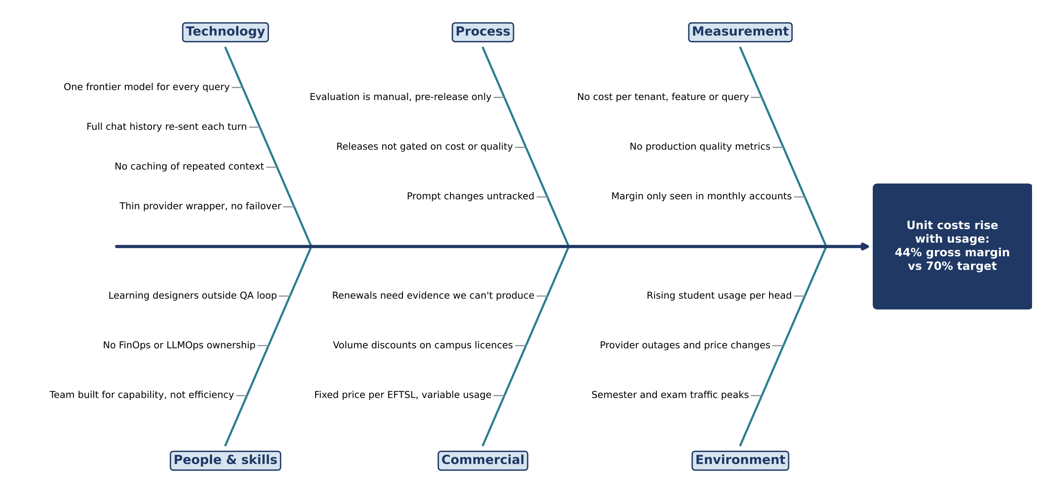
Figure 2. Fishbone diagram of the causes of Lyra's gross-margin gap
Table 3. 5 Whys analysis of the margin gap
Why? | Answer
1. Why is gross margin 44% instead of 70%? | Model-inference cost takes about 41% of licence revenue.
2. Why is inference so expensive? | Every question goes to the most capable and most expensive model, with the full conversation history attached.
3. Why is every question sent to the frontier model? | Lyra has no evidence that a cheaper model would answer simple questions just as well, so the safe default is the best model.
4. Why is there no such evidence? | Answer quality is measured manually, offline and only before releases; nothing measures quality per question in production or links cost to quality.
5. Why is there no continuous measurement? | The platform was built to prove the product worked, not to run it efficiently. Nobody owns LLM operations (LLMOps) or FinOps, and there is no shared tooling for tracing, evaluation or cost attribution.
Root cause | There is no continuous measurement and control layer between Lyra's application and the models it calls.

Table 4. SWOT summary
Strengths | Weaknesses
- Grounded, cited answers from approved content  - LTI 1.3 distribution and onshore data  - Senior ML team and an existing evaluation harness | - Single-model architecture and no caching  - Quality measured only offline  - No cost attribution per tenant or feature

Opportunities | Threats
- Small models are now far cheaper (Claude Haiku 5.5 lists at USD 0.10 per million input tokens versus USD 2 for Sonnet 5.5)  - Prompt caching and Australian cross-Region inference on Amazon Bedrock  - Universities want auditable AI (TEQSA) | - LMS vendors adding generic AI features  - Free consumer tools  - Provider outages and price changes  - New automated-decision transparency duties from December 2026

The analysis shows that the symptom (cost) and the root cause (no measurement or control layer) are different. Cutting cost alone, for example by moving everyone to a cheaper model, would put the grounding promise at risk, so the solution must measure quality and cost together and act on both.
Draft IT-Enabled Proposal
Proposed IT initiative (High level idea)
We propose Project ATLAS (Adaptive, Trusted LLM Assurance and Serving), a control layer between Lyra's retrieval application and the language models it calls. It has five components (Figure 3):
- Model gateway – the open-source LiteLLM proxy (BerriAI, n.d.) in Lyra's AWS Sydney environment. Every model call passes through it. It enforces per-university keys, budgets and rate limits, fails over to a second provider, and calls Claude models through Amazon Bedrock's Australian cross-Region inference so data stays onshore (Choo et al., 2025).
- Adaptive router – a small classifier trained on Lyra's graded question history that predicts whether a cheaper model can answer as well as the frontier model. Learned routers have cut costs by more than half without losing quality (Chen et al., 2023; Ong et al., 2025).
- Caching – prompt caching for the stable parts of each request, plus a semantic cache that reuses verified answers to near-identical questions within the same unit and university (Bang, 2023).
- Continuous evaluation and tracing – every request is traced in self-hosted Langfuse (Langfuse, n.d.); samples are scored for faithfulness, relevance and citation accuracy using RAGAs-style metrics (Es et al., 2024) and reviewed by learning designers. Every code or prompt change must pass an evaluation gate before release.
- FinOps and tenant insight – dashboards show cost per question, per university and per feature alongside quality, which Customer Success uses as evidence in quarterly business reviews.
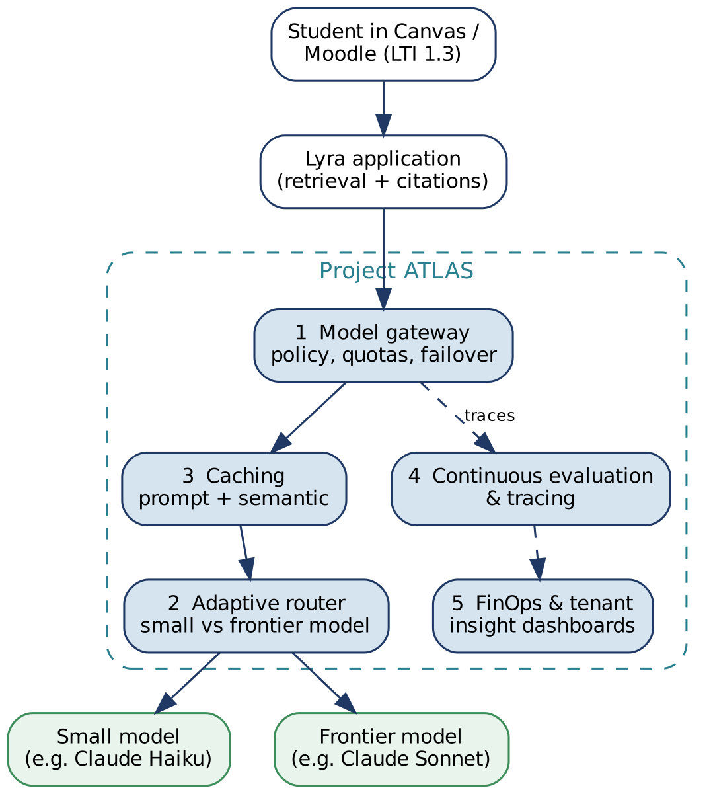
Figure 3. Concept of Project ATLAS: one control layer between Lyra's application and the models it calls
Each component exists today as an open-source tool or cloud service. What is new is combining them around quality-gated cost optimisation: no saving goes live unless measured answer quality holds. Modelling shows ATLAS can reduce inference cost from AUD 0.053 to about AUD 0.012–0.015 per question, a reduction of roughly 72–77%. The detailed design and estimates are in AW6.
Business Value Proposition
In the business–IT alignment model, ATLAS is an IT investment that builds new IT capabilities (LLM operations and FinOps) to strengthen business capabilities (affordable delivery and evidence-based customer success), creating organisational value for universities, students and Lyra (The University of Sydney, 2026). Table 5 shows how it changes four blocks of the BMC.
Table 5. How ATLAS improves Lyra's Business Model Canvas
BMC block | Current state | With ATLAS
Cost Structure | Inference about AUD 8.94 per EFTSL per year; gross margin about 44% | Inference about AUD 2.52 per EFTSL; gross margin about 72%; about AUD 1.5 million a year retained at 250,000 EFTSL
Value Proposition | Grounding is claimed and checked offline | Grounding is measured continuously and reported per university, so the trust claim can be audited
Customer Relationships | Quarterly business reviews report usage only | Reviews report usage, answer quality and cost, giving evidence for renewal and expansion
Key Partnerships / Resources | Single-provider dependency; 4.5 hours of outage in Semester 1, 2026 | Multi-provider failover targeting 99.9% availability; evaluation data becomes a proprietary asset

ATLAS supports all three FY2027 objectives. It is the main lever for the 70% gross margin; it underpins 90% renewal by giving Customer Success hard evidence of quality; and it supports eight licences because a lower unit cost lets Lyra price campus-wide licences competitively as usage grows. It also makes Lyra more resilient to provider price changes and outages.
Preliminary Constraints
Table 6. Preliminary constraints and initial responses
Constraint | Description | Initial response
Budget and capacity | Lyra is seed-funded with 34 staff. About 9 FTE for six months delays other roadmap work. | Business case with a short payback; about AUD 1.41 million including contingency, AUD 0.46 million new cash (AW6).
Timeline | Teaching calendars set the deadline: the gateway must be live before Semester 1, 2027 begins in late February. | 26-week plan from 2 November 2026 to 30 April 2027, with careful in-semester rollout (AW4).
Quality risk | A router that sends hard questions to a small model would weaken the grounding promise. | Quality floor, evaluation gates, shadow and canary releases, automatic rollback.
Privacy, residency and compliance | Student questions are personal information under the Privacy Act 1988 (Cth). New automated-decision transparency duties start on 10 December 2026 (Eslaieh, n.d.). | Onshore traces and caches, data minimisation, privacy impact assessment and transparency statement.
Skills | Strong ML team, but limited experience running LLM gateways, semantic caches and FinOps. | Training and some external expertise (AW6, AW8).
Resistance | Engineers may see evaluation gates as slowing them down; academics may distrust a 'cheaper model'; university security teams will review any architecture change. | Change management plan (AW8) and stakeholder engagement (AW5).
Vendor dependency | Open-source components and cloud features change quickly. | Avoid replacing one lock-in with another; keep components swappable.

These constraints shape the rest of this report: the delivery method (AW4), stakeholder engagement (AW5), estimates (AW6), governance (AW7), change management (AW8), quality assurance (AW9), risk (AW10) and ethics (AW11).
References
Anthropic. (2026). Pricing [Claude Platform documentation]. Retrieved October 9, 2026, from https://platform.claude.com/docs/en/about-claude/pricing
Bang, F. (2023). GPTCache: An open-source semantic cache for LLM applications enabling faster answers and cost savings. In Proceedings of the 3rd Workshop for Natural Language Processing Open Source Software (NLP-OSS 2023). Association for Computational Linguistics. https://aclanthology.org/2023.nlposs-1.24
BerriAI. (n.d.). LiteLLM documentation: Proxy server (LLM gateway). Retrieved October 9, 2026, from https://docs.litellm.ai/docs/simple_proxy
Chen, L., Zaharia, M., & Zou, J. (2023). FrugalGPT: How to use large language models while reducing cost and improving performance (arXiv:2305.05176). arXiv. https://doi.org/10.48550/arXiv.2305.05176
Choo, D., Chiao, S., Dean, J., Motohashi, K., Li, M., Trikande, S., & Jones, G. (2025, October 31). Introducing Amazon Bedrock cross-Region inference for Claude Sonnet 4.5 and Haiku 4.5 in Japan and Australia. AWS Machine Learning Blog. https://aws.amazon.com/blogs/machine-learning/introducing-amazon-bedrock-cross-region-inference-for-claude-sonnet-4-5-and-haiku-4-5-in-japan-and-australia/
Corporations Act 2001 (Cth). https://www.legislation.gov.au/C2004A00818/latest
Es, S., James, J., Espinosa-Anke, L., & Schockaert, S. (2024). RAGAs: Automated evaluation of retrieval augmented generation. In Proceedings of the 18th Conference of the European Chapter of the Association for Computational Linguistics: System Demonstrations. Association for Computational Linguistics. https://aclanthology.org/2024.eacl-demo.16
Eslaieh, G. (n.d.). Automated decision making: Preparing for the new transparency obligation. Corrs Chambers Westgarth. Retrieved October 9, 2026, from https://corrs.com.au/insights/automated-decision-making-preparing-for-the-new-transparency-obligation
Gartner. (2024, July 29). Gartner predicts 30% of generative AI projects will be abandoned after proof of concept by end of 2025 [Press release]. https://www.gartner.com/en/newsroom/press-releases/2024-07-29-gartner-predicts-30-percent-of-generative-ai-projects-will-be-abandoned-after-proof-of-concept-by-end-of-2025
International Organization for Standardization. (2024). Information technology: Governance of IT for the organization (ISO/IEC Standard No. 38500:2024). https://www.iso.org/standard/81684.html
Ishikawa, K. (1990). Introduction to quality control. 3A Corporation.
Langfuse. (n.d.). Langfuse documentation: Open source LLM engineering platform. Retrieved October 9, 2026, from https://langfuse.com/docs
Mintzberg, H. (1979). The structuring of organizations: A synthesis of the research. Prentice-Hall.
National Artificial Intelligence Centre. (2025). Guidance for AI adoption. Department of Industry, Science and Resources. https://www.industry.gov.au/publications/guidance-ai-adoption
Ong, I., Almahairi, A., Wu, V., Chiang, W.-L., Wu, T., Gonzalez, J. E., Kadous, M. W., & Stoica, I. (2025). RouteLLM: Learning to route LLMs from preference data. In Proceedings of the Thirteenth International Conference on Learning Representations (ICLR 2025). https://arxiv.org/abs/2406.18665
Privacy Act 1988 (Cth). https://www.legislation.gov.au/C2004A03712/latest
The University of Sydney. (2026). Week 02: Creating organisational value from IT investments [Lecture slides]. INFO5990 Professional Practice in IT, Canvas.
Weill, P., & Ross, J. W. (2004). IT governance: How top performers manage IT decision rights for superior results. Harvard Business School Press.

